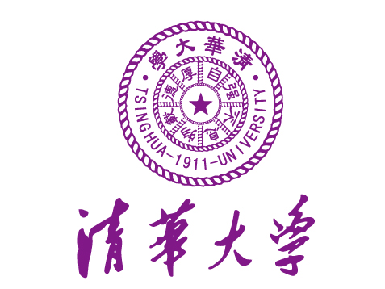

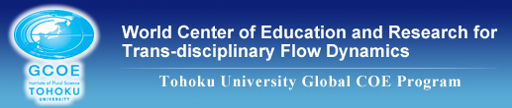
First Announcement

The Maintenance & Interdisciplinary Science Summer School 2012

Beijing, China
July 16-20, 2012

OVERVIEW

We are pleased to announce that the 3rd Maintenance & Interdisciplinary Science Summer School will be held this summer. This event is organized by Tsinghua University, the Japan Society of Maintenology, and the GCOE Program “World Center of Education and Research for Trans-disciplinary Flow Dynamics of Tohoku University.

The summer school aims at providing participants with the opportunity to learn practice and theory for the maintenance activities of nuclear power plants. It also intends to the friendship exchange of students and young researchers in Asian countries.

SCHEDULE (Tentative)

Venue: In Tsinghua University
Welcome Reception: Evening of July 16th
Summer School: July 16th – 20th (Including Lectures, Presentations, Laboratory visits, Beijing historical visit, and Free activities)
Banquet: July 17th
Accommodation: In Tsinghua University
COST
No fee is required for registration.
Daily expenses (including local transportation and accommodation) during your stay in Beijing from July 16th to 20th will be covered by the host. Please note, however, that the participants will have to pay for their own airfare tickets to and from Beijing.

HOW TO APPLY
Please complete the application form (application.doc) and forward it by e-mail to the secretariat of Tsinghua University at czpdme@tsinghua.edu.cn.

CAPACITY
30 students

Deadline for application is May 31, 2012.

